**Single Phase Single Pulse Modulation Inverter**

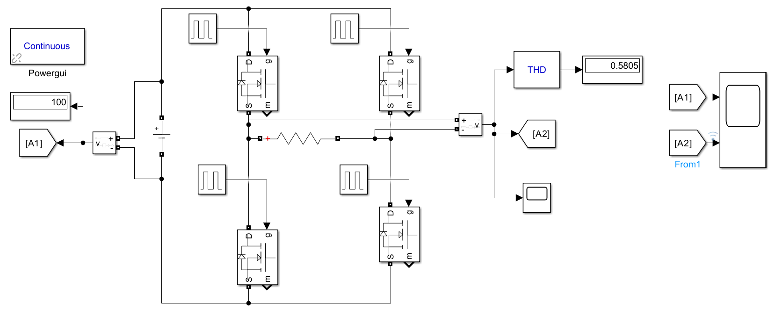

**Fig. Block Diagram of Single-Phase Single Pulse Modulation Inverter**



**Fig. Characteristics of Single-Phase Single Pulse Modulation Inverter**



**Fig. THD of Single-Phase Single Pulse Modulation Inverter**

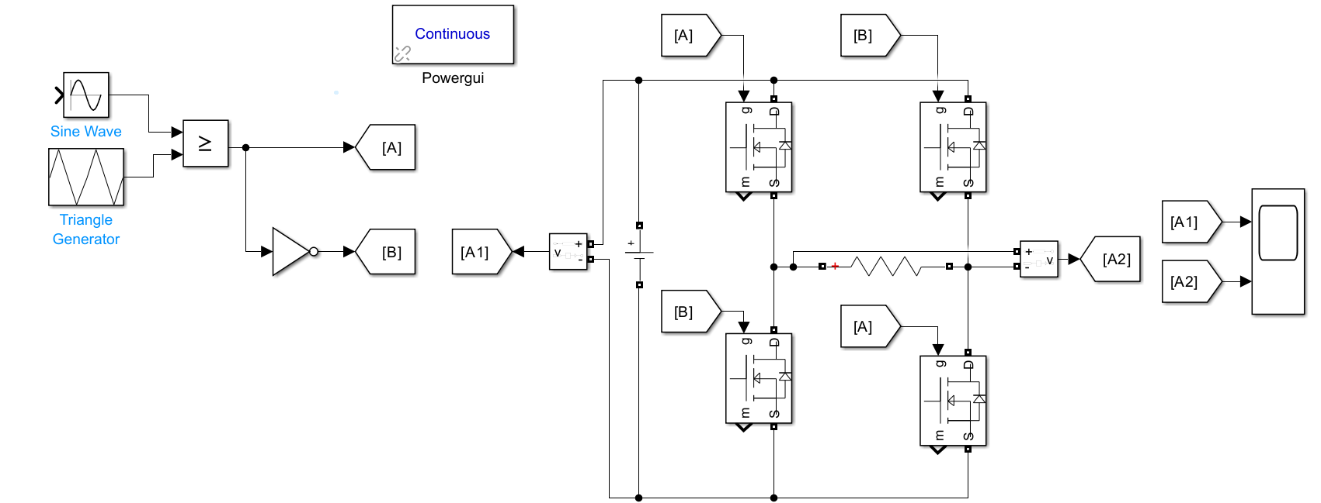

**Fig. Block Diagram of Bipolar SPWM Rectifier**



**Fig. Characteristics of Bipolar SPWM Rectifier**

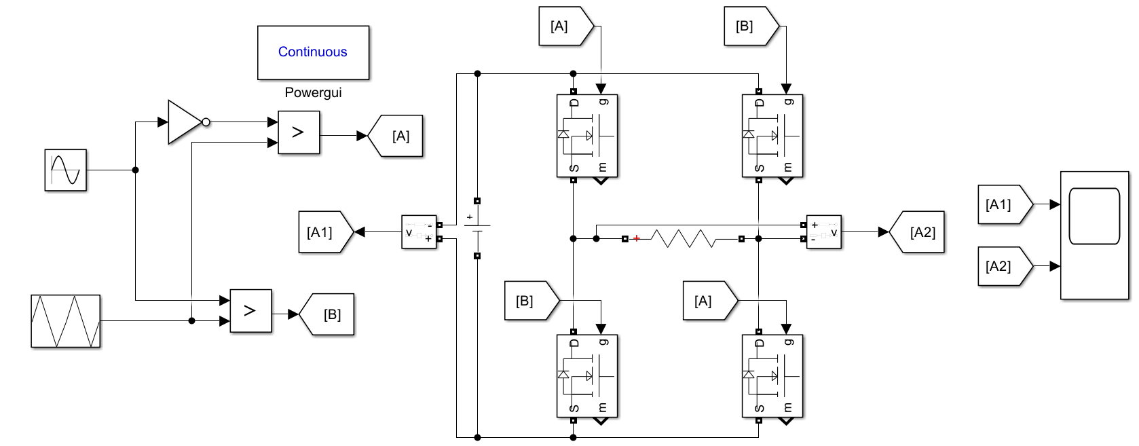

**Fig. Block Diagram of Unipolar SPWM Rectifier**



**Fig. Characteristics of Unipolar SPWM Rectifier**